

Wallet Walkthrough – Hands-on Wallet Setup   
  
**Objective/Aim:**



To learn how to create and use a cryptocurrency wallet, understand the importance of private keys, public addresses, and safely manage digital assets.

**Apparatus/Software Used:**

Laptop/PC or Mobile Phone

MetaMask Wallet

Browser Extension or Mobile App

Internet connection

**Theory/Concept:**

**What is a Crypto Wallet?**

A digital tool to **store, send, and receive cryptocurrency**.

Wallets store **private keys** (for access) and **public addresses** (for receiving crypto).



**Procedure:**

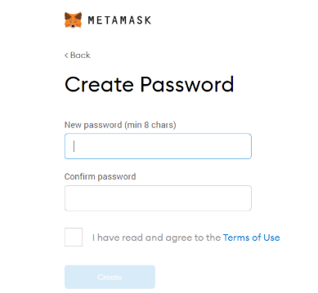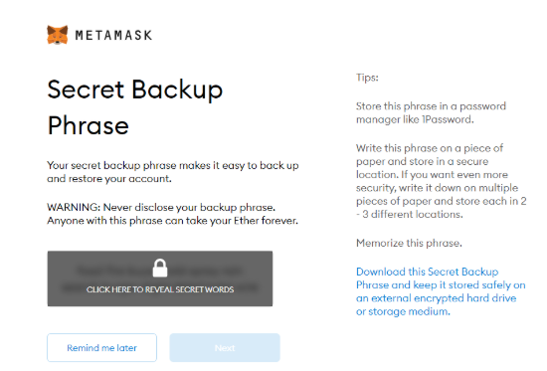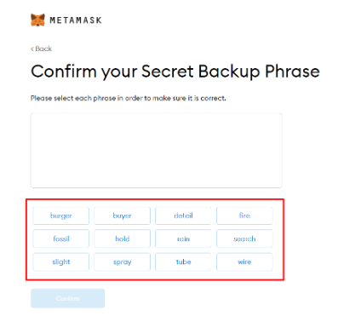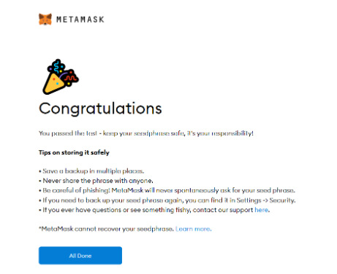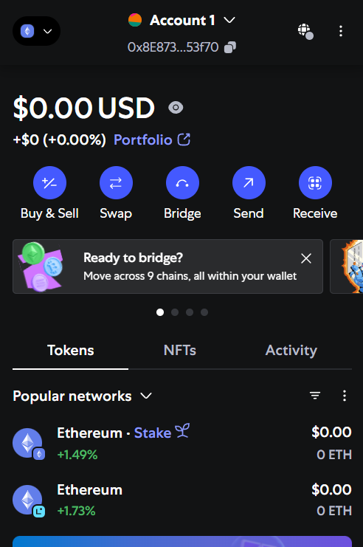

* Install metamask browser extension.
* Click Create a New Wallet.
* Securely write down the Seed Phrase and store it safely.
* After setup, access the public address to receive crypto.

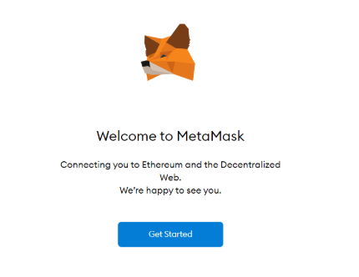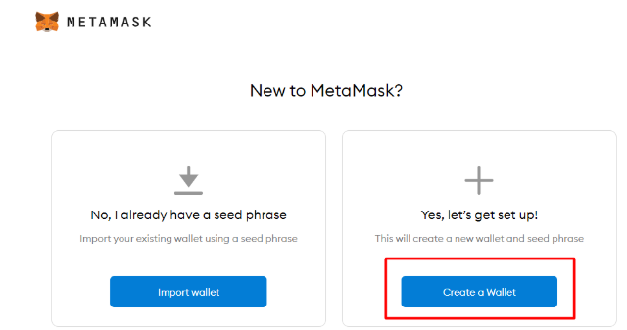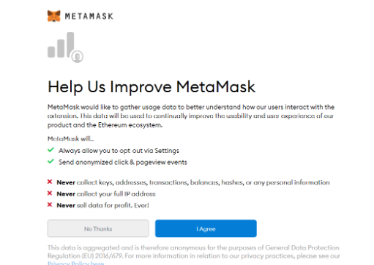

**Observation :-**

MetaMask wallet installed successfully.

New wallet created with a secure password.

12-word seed phrase generated and saved safely.

Private key do not share with anyone

Unique public address assigned.

Transaction visible on blockchain explorer.

AAA



|  |  |  |  |
| --- | --- | --- | --- |
|  |  |  |  |
|  |  | nbvnvnvx |  |
|  |  |  |  |
|  |  |  |  |
|  |  |  |  |
|  |  |  |  |
|  |  |  |  |